
MeetMind-AI
Project Information

August 12, 2026
Muhammad Fahad
- [Company address]

1. Project Name:
MeetMind AI — Intelligent Meeting Transcription,
Summarization & Knowledge Retrieval System

2. Objective
MeetMind AI is an enterprise-grade AI-powered meeting intelligence ecosystem consisting of a React Web Application, a Manifest V3 Chrome Extension, and a Python FastAPI Backend.
The platform captures, transcribes, processes, and stores meeting audio and notes in real time. Leveraging Retrieval-Augmented Generation (RAG) and structured LLM pipelines, MeetMind AI automatically generates structured meeting summaries, extracts actionable tasks, identifies key decisions, and enables contextual multi-session Q&A across meeting history.

3. Key Features
- Multi-Channel Meeting Capture: Capture audio and meeting context directly from browser-based platforms (Google Meet, Zoom Web, Microsoft Teams) via Chrome Extension or upload recorded audio/transcripts via the Web App.
- Automated Audio Pipeline & Transcription: Multi-provider Whisper and LLM integration for fast, accurate speech-to-text conversion.
- Structured Information Extraction: Uses strict Pydantic schemas on the backend to parse:
- Executive Summaries: Concise meeting overviews with main discussion points.
- Action Items & Tasks: Assigned owners, deadlines, and priority levels.
- Key Decisions & Highlights: Formal logging of decisions made during discussions.
- RAG-Powered Meeting Chat (Vector Database): Embedded semantic search (ChromaDB / FAISS) allowing users to query single or across historical meetings (e.g., "What did we decide about the API budget last week?").
- Multi-Provider AI Key Manager: Dynamic fallback & switching across OpenAI, Groq, Google Gemini, and local Ollama models.
- Modern Web Interface: Dark mode glassmorphism UI built with React, TypeScript, Tailwind CSS, and Framer Motion micro-animations.
- Chrome Extension (Manifest V3): Sidepanel and popup integration providing one-click meeting controls, audio capture, and quick status monitoring.

4. Tools & Technologies
- Backend (Python API)
- Framework: Python 3.10+, FastAPI, Uvicorn
- Data Validation: Pydantic V2 (structured output parsing for LLM calls)
- AI & LLM Services: OpenAI API, Groq SDK, Google Gemini API, Ollama (Local LLM support)
- Embeddings & Vector Database: ChromaDB / FAISS, Sentence-Transformers / OpenAI Embeddings
- Audio Processing: OpenAI Whisper API / Faster-Whisper, PyDub
- Testing & Quality: PyTest, HTTPX, Logging system with detailed audit trails
- Frontend (React Web Application)
- Framework: React 18, Vite, TypeScript
- State & Forms: React Hook Form (RHF) with Zod validation schema
- Styling & UI: Tailwind CSS, Framer Motion (page transitions & micro-interactions), Lucide Icons
- API Layer: Axios / Fetch with centralized API service architecture
- Testing: Vitest, React Testing Library
- Chrome Extension
- Standard: Manifest V3 compliant
- Components: Background Service Worker, Content Scripts (DOM listener/injector), Side Panel UI & Popup
- Build System: Vite + Custom build/copy workflows with TypeScript

5. System Architecture
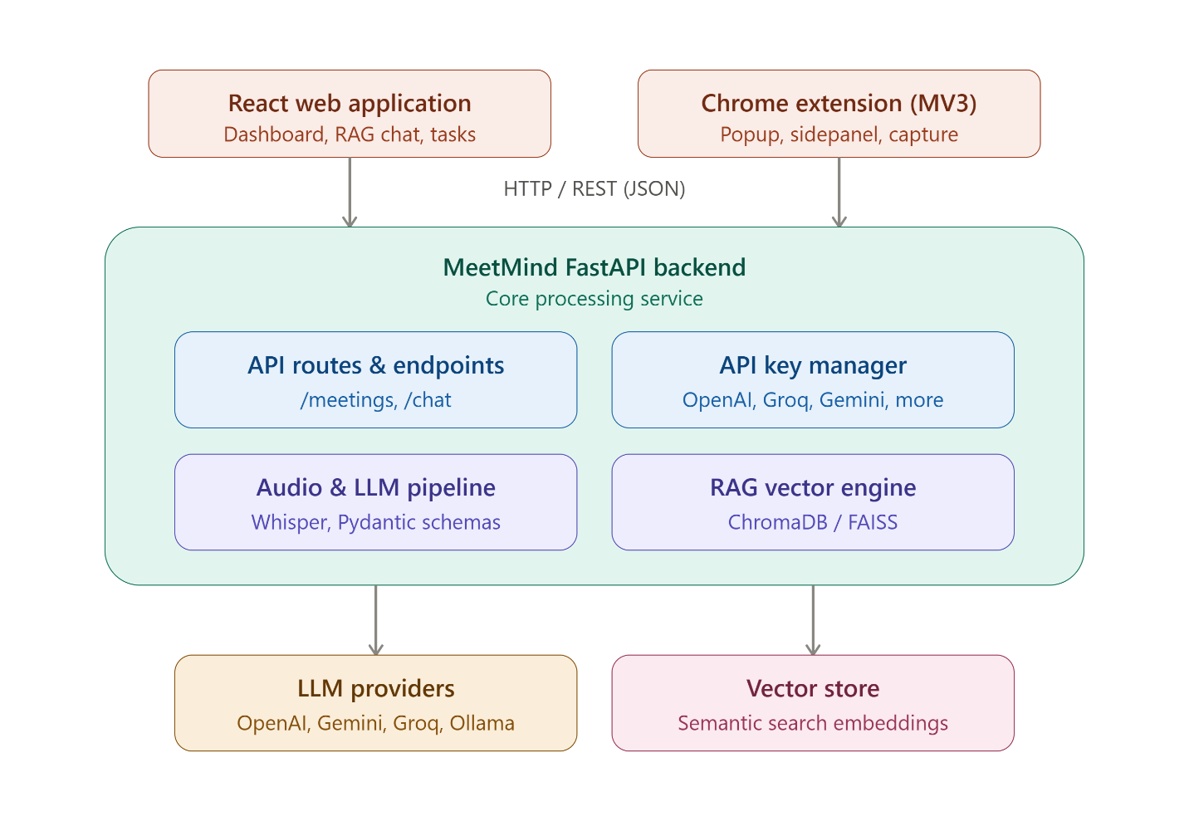

6. Team Members
Team Lead / Full-Stack Engineer: Muhammad Fahad

7. Current Progress & Project Status
Module | Status | Description
Backend API Core | Completed | FastAPI setup with health check endpoints, CORS middleware, multi-provider API Key Manager, and endpoint routing (/api/v1/meetings, /api/v1/chat).
LLM & Audio Pipeline | Completed | Structured schema parsing via Pydantic for summaries, action items, and key decisions. Multi-LLM provider abstraction.
Vector DB / RAG | Completed | Vector store integration for historical meeting search and retrieval-augmented conversational chat.
React Web App | Completed | Modular component structure with Tailwind dark-mode glassmorphism design, interactive modals (ConfirmModal, DecisionItem), task management views, and chat interface.
Chrome Extension | Completed | Manifest V3 build system configured, background service worker, popup UI, side panel integration, and dynamic icon generation scripts.
Configuration & Security | Completed | Environment-based configuration (.env), zero hardcoded secrets, strict input validation, and proper CORS restrictions.
Unit Testing & QA | Active / Ongoing | Unit tests implemented for backend modules (tests/) and frontend components (Popup.test.tsx, UI component tests). Full integration test pass ongoing.

8.Frontend:
